**CLOUD MANUFACTURING ARCHITECTURE BASED ON PUBLIC BLOCKCHAIN TECHNOLOGY**

**by**

**BS. SATHISHKUMAR**

**(Reg. No: 4151610075)**

**A PROJECT REPORT**

Submitted to the

**DEPARTMENT OF COMPUTER SCIENCE AND APPLICATIONS**

*In partial fulfillment of the requirements*

*for the award of the degree*

*of*

**INTEGRATED BCA-MCA**

**Under the guidance of**

**Mr. SENTHILKUMAR. S, MCA., M.Phil.,**



**SCHOOL OF ARTS AND SCIENCE, AV CAMPUS**

**VINAYAKA MISSION’S RESEARCH FOUNDATION**

**PAIYANOOR – 603104**

**JUNE, 2021**

**School of Arts and Science, AV Campus**

**Vinayaka Mission’s Research Foundation**

**Paiyanoor-603104**

**DEPARTMENT OF COMPUTER SCIENCE APPLICATIONS**

**CERTIFICATE**

Certified that this project report titled **CLOUD MANUFACTURING ARCHITECTURE BASED ON PUBLIC BLOCKCHAIN TECHNOLOGY** is the bonafied work of **Mr. SATHISHKUMAR BS**, Reg.No:4151610075 who carried out the research under my supervision. Certified further, that to the best of my knowledge the work reported here in does not form part of any other project report or dissertation on the basis of which a degree or award was conferred on an earlier occasion on this or any other candidate.

**Internal Guide Head Of the Department**

The VIVA-VOCE examination was conducted on………….……….……………. at School of Arts & Science, AV Campus

**Internal Examiner External Examiner**

**ACKNOWLEDGEMENT**

It is my privilege of express my gratitude and respect to those who have guided me and inspired me during course of the project work. At every outset I express my gratitude to almighty lord for showing his grace and blessing upon me to complete this project.

First and foremost, I express my sincere gratitude to our honourable **Director**

**Dr. R. Shanmugavalli Ph.D.** providing necessary infrastructure and permitting me to complete the project

I wish to thank our HoD **Dr. S. Kavitha, MCA, M.Tech, Ph.D,** who provided all facilities and helped during course of study.

I express my gratitude and thank to **Mr. S. SENTHILKUMAR, MCA., M.Phil.,** for her valuable internal guidance, motivation and necessary help in the successful completion of this project.

I also extend my thanks to other faculties for their cooperation during my course. Finally I would like to thank my parents, teachers and friends for their support and cooperation to complete this project.

**SATHISHKUMAR BS**

|  |  |  |
| --- | --- | --- |
| **S.NO** | **CONTENT** | **PAGE NO** |
| **1** | **ABSTRACT** | 1 |
| **2** | **LIST OF TABLES** | 2 |
| **3** | **LIST OF FIGURES** | 3 |
| **4** | **LIST OF SYMBOLS** | 4 |
| **5** | **CHAPTERS** | 5 |
|  | **5.1 INTRODUCTION** | 5 |
|  | **5.2 SYSTEM ANALYSIS** | 5 |
|  | **5.2.1 REQUIREMENT ANALYSIS** | 5 |
|  | 5.2.1.1 SOFTWARE ANALYSIS | 5 |
|  | 5.2.1.2 HARDWARE ANALYSIS | 5 |
|  | **5.2.2 SOFTWARE SPECIFICATIONS** | 6 |
|  | 5.2.2.1 MYSQL | 6 |
|  | 5.2.2.2 JAVA | 7 |
|  | 5.2.2.3 ECLIPSE | 8 |
|  | **5.3 SYSTEM DESIGN** | 9 |
|  | 5.3.1 DATA FLOW | 9 |
|  | 5.3.2 DATA FLOW SYMBOLS | 10 |
|  | 5.3.3 ARCHITECTURE DIAGRAM | 11 |
|  | 5.3.4 DESIGN PROCESS | 12 |
|  | 5.3.5 CLASS DIAGRAM | 14 |
|  | 5.3.6 ACTIVITY DIAGRAM | 15 |
|  | 5.3.7 DATABASE DESIGN  5.3.8 TABLE DESIGN | 16  17 |
|  | 5.3.9 MODULE SPECIFICATION | 19 |
|  | 5.3.10 MODULE DESCRIPTION | 20 |
|  | 5.4 SYSTEM TESTING  5.5 RESULTS  5.5.1 CONCLUSION  5.5.2 LIMITATION  5.5.3 FUTURE ENHANCEMENT | 22  24  25  25 |
| 6 | APPENDICES | 26 |
|  | 6.1 CODING | 26 |
|  | 6.2 SCREENSHOT | 63 |
|  | REFERENCE | 70 |
|  |  |  |

**1.ABSTRACT**

With Industry 4.0, IT infrastructure has started to be used more effectively in the manufacturing sector. Cyber physical systems, IoT, cloud manufacturing, big data are some of the technologies that make up the concept of Industry 4.0. These technologies have solved many problems in the manufacturing sector. One of these technologies, cloud manufacturing technology, has emerged with the idea of pay as you go. This technology has enabled manufacturing resources to be leased and shared on a global scale. However, it has problems arising from its central structure and the need for a reliable 3rd party. Reliability, security, continuity, scalability, data lock-in, single point failure, data manipulation are some of the main problems. Blockchain (BC) is a decentralized and distributed technology. The data stored on the BC network cannot be altered in any way. With these features, we believe that BC-supported cloud manufacturing systems can overcome the aforementioned problems and eliminates the need for a reliable 3rd party. Based on this belief, in this study the agreements and communication between the resource provider and the customer, which is one of the basic functions of cloud manufacturing platforms, are realized with a decentralized application using BC-based smart contracts (SCs). The designed application is called the decentralized cloud manufacturing application (DCMApp). DCMApp does not operate on a fully public BC network, it has a hybrid structure and uses the Ethereum network as a public BC network. These features make DCMApp different from other BC-based cloud manufacturing applications. DCMApp’s hybrid structure has enabled more transparent, economic and safe manufacturing agreements. It is also possible to store agreements on the BC network at a low cost without installing any server infrastructure. The use of Ethereum network makes it almost impossible to manipulate agreements.

**2. LIST OF TABLES**

|  |  |  |  |
| --- | --- | --- | --- |
| **S.NO** | **TABLE NO** | **TABLE NAME** | **PAGE NO** |
| 1 | 5.3.8.1 | Register table | 17 |
| 2 | 5.3.8.2 | Upload files | 17 |
| 3 | 5.3.8.3 | Transaction | 18 |
| 4 | 5.3.8.4 | Request | 18 |
| 5 | 5.3.8.5 | Attack | 18 |

**3.LIST OF FIGURES**

|  |  |  |  |
| --- | --- | --- | --- |
| **S.NO** | **FIGURE NO** | **FIGURE NAME** | **PAGE NO** |
| **1** | **5.3.1.1** | **Data Flow** | **09** |
| **2** | **5.3.3.1** | **Architecture** | **11** |
| **3** | **5.3.5.1** | **Class Diagram** | **14** |
| **4** | **5.3.6.1** | **Activity diagram** | **15** |
| **5** | **5.3.7.1** | **Database design** | **16** |
| **6** | **6.2.1** | **Home Page** | **63** |
| **7** | **6.2.2** | **Register Page** | **63** |
| **8** | **6.2.3** | **Login Page** | **64** |
| **9** | **6.2.4** | **Add Website** | **64** |
| **10** | **6.2.5** | **File upload** | **65** |
| **11** | **6.2.6** | **Admin Login** | **65** |
| **12** | **6.2.7** | **Login Success** | **66** |
| **13** | **6.2.8** | **View Websites** | **66** |
| **14** | **6.2.9** | **View Attackers** | **67** |
| **15** | **6.2.10** | **Attacking Folder** | **67** |
| **16** | **6.2.11** | **Attack File Upload** | **68** |
| **17** | **6.2.12** | **Attacking Process** | **68** |
| **18** | **6.2.13** | **Recover Files** | **69** |

**4.LIST OF SYMBOLS**

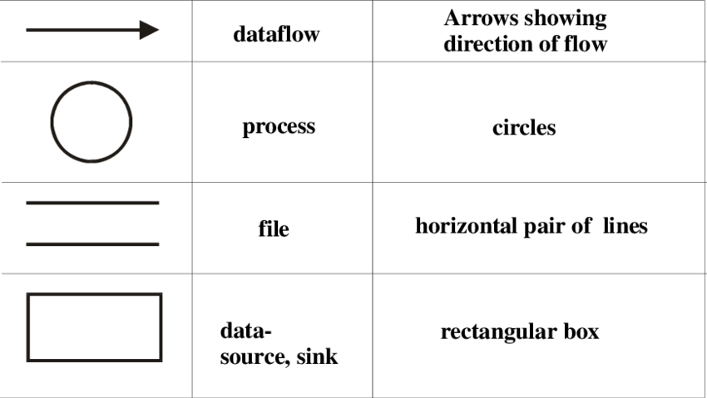

**5.CHAPTER**

**5.1 INTRODUCTION**

TECHNOLOGICAL developments in manufacturing systems have changed the competitive factors in the sector. Before 1970s, cost, which is one of these factors, one the most important factor, whereas quality gained importance after the 70s. By 1990s, service and environmental factors gained importance and in the 21st century, information became the most important factor.

The information is the foundation of the 4th industrial revolution, namely, Industry 4.0. The term Industry 4.0 collectively refers to a wide range of current concepts, including cyber-physical systems (CPS), internet of things (IoT), simulation, cloud computing, big data and advanced analysis techniques, service-oriented technologies, virtualisation and so on.

**5.2 SYSTEM ANALYSIS**

**5.2.1 REQUIREMENT ANALYSIS**

**5.2.1.1 Software Analysis**

Operating System : Windows 7

Front end : JAVA

Back end : MY-SQL

Tools : Eclipse Oxygen

**5.2.1.2 Hardware Analysis**

System : Pentium IV 2.4 GHz.

Hard Disk : 40 GB.

Floppy Drive : 1.44 Mb.

Monitor : 15 VGA Colour.

Mouse : Logitech.

RAM : 256 Mb.

**5.2.2 SOFTWARE SPECIFICATIONS**

##### 5.2.2.1 MYSQL

Basic MySQL administration tools, Usually only the root user has permission to create new databases and new users for the MySQL server. The MySQL user is independent of any other username. This means that an individual may use more than one MySQL username. To enter the MySQL interface as root:

unixprompt> mysql -u root -p Enter password:

mysql>

Create a MySQL database

It is easy to create a new MySQL table within the MySQL prompt.

mysql> CREATE DATABASE tissueinfo;

Users, passwords, and privileges

We now have an empty database, but we don’t yet have any users to access this database. To simultaneously create a user, assign a password, and grant access to this newly created database enter:

mysql> GRANT USAGE ON tissueinfo.* to wbyeats@localhost

IDENTIFIED BY ’ode2maud’;

This creates the user “wbyeats” if it doesn’t already exist, and sets the password to “ode2maud”. Note that if the user “wbyeats” already exists the password will be set to “ode2maud” (even if the password was previously set to something diﬀerent). This statement also grants wbyeats access to all of the tables within the tissueinfo database (specified by “tissueinfo.*”).

One of the attractive features of MySQL is the strict security it gives your data. The tradeoﬀ is some extra work for the database administrator, because access privileges must be individually set.

Which gives “wbyeats” permission to look at data (SELECT) and to add new data (INSERT). If you trust “wbyeats” you can grant all possible permissions (includ-ing permission to delete any data in the database) with the simple statement:

**5.2.2.2 JAVA**

Java is a powerful object-oriented programming language introduced by Sun Microsystems in 1995, which has built-in support to create programs with a graphical user interface (GUI), utilize the Internet, create client-server solutions, and much more. Programs written in Java can run, without change, on any of the common computer operating systems Windows 95/NT, Macintosh, and Unix. A variant of Java programs called applets can be embedded inside a web page and execute on the computer that is viewing the page, automatically and in a secure environment.

As a language, Java is closely related to C++, which is also object-oriented but retains a lot of idiosyncrasies inherited from its predecessor language C. Java has removed the inconsistent elements from C++, is exclusively object-oriented, and can be considered a modern version of C++.[1] Because of its logical structure Java has quickly become a popular choice as a teaching language,[2] and because of its extensive Internet support and the promise of writing programs once and using them on every operating system Java is becoming more and more accepted in industry.

Definition: Basic Java Programming Guidelines

Every Java program must follow these guidelines:

Java is case sensitive, i.e. the word Program is different from program.

Curly brackets { and } are used to group statements together.

An executable Java program must contain at least the following lines as a framework:

public class Name

{ public static void main(String args[])

{ ... program code ...

}

}

Every statement whose next statement is not a separate group must end in a semicolon.

**5.2.2.3 ECLIPSE**

Eclipse is an integrated development environment (IDE) for developing applications using the Java programming language and other programming languages such as C/C++, Python, PERL, Ruby etc.

The Eclipse platform which provides the foundation for the Eclipse IDE is composed of plug-ins and is designed to be extensible using additional plug-ins. Developed using Java, the Eclipse platform can be used to develop rich client applications, integrated development environments and other tools. Eclipse can be used as an IDE for any programming language for which a plug-in is available.

The Java Development Tools (JDT) project provides a plug-in that allows Eclipse to be used as a Java IDE, PyDev is a plugin that allows Eclipse to be used as a Python IDE, C/C++ Development Tools (CDT) is a plug-in that allows Eclipse to be used for developing application using C/C++, the Eclipse Scala plug-in allows Eclipse to be used an IDE to develop Scala applications and PHPeclipse is a plug-in to eclipse that provides complete development tool for PHP.

Eclipse contains a base workspace and an extensible plug-in system for customizing the development environment. Eclipse is thus also a framework in addition to an IDE and can be extended to have more features and functionalities through the use of plugins.  For instance, if you need to use SVN functionality or develop Adobe Flex applications there are plugins for them. If you need to install more plugins, you can navigate to Help > Install new software and install them.

If you have chosen the right distribution of eclipse, you will have most needed plugins already installed. Eclipse distributions are customized eclipse versions for a particular use case or particular user group with all required or helpful plugins for that particular purpose. Some of the popular distributions are Eclipse IDE for Java Developers, Eclipse IDE for Java EE Developers, Eclipse for Mobile Developers, Eclipse Modeling Tools, and Eclipse for Testers. So you need to decide which distribution suites you most. For executing java and java ee programs, as is the case mostly, you will need Eclipse IDE for Java EE Developers.

**5.3 SYSTEM DESIGN**

**5.3.1 DATA FLOW**



**Fig 5.3.1.1 Data Flow**

**5.3.2 DATA FLOW SYMBOLS**

**------------------------- START / END**

**------------------------- STOP**

**------------------------- OBJECT**

**------------------------- FLOWCHART LINK**

**--------------------------- CONNECTION**

**5.3.3 ARCHITECTURE DIAGRAM**

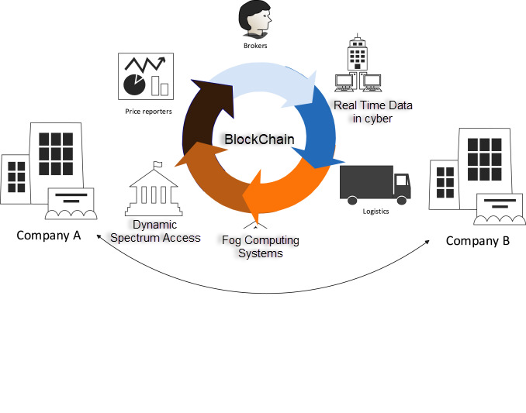

**Fig. 5.3.3.1 Architecture**

**5.3.4 DESIGN PROCESS**

**Systems design** is the process or art of defining the architecture, components, modules, interfaces, and data for a system to satisfy specified requirements. One could see it as the application of systems theory to product development. There is some overlap and synergy with the disciplines of systems analysis, systems architecture and systems engineering.

**1 INTRODUCTION**

**Purpose and Scope**

This section provides a brief description of the Systems Design Document’s purpose and scope.

**Project Executive Summary**

This section provides a description of the project from a management perspective and an overview of the framework within which the conceptual system design was prepared. If appropriate, include the information discussed in the subsequent sections in the summary.

System Overview

This section describes the system in narrative form using non-technical terms. It should provide a high-level system architecture diagram showing a subsystem breakout of the system, if applicable. The high-level system architecture or subsystem diagrams should, if applicable, show interfaces to external systems. Supply a high-level context diagram for the system and subsystems, if applicable. Refer to the requirements trace ability matrix (RTM) in the Functional Requirements Document (FRD), to identify the allocation of the functional requirements into this design document.

Design Constraints

This section describes any constraints in the system design (reference any trade-off analyses conducted such, as resource use versus productivity, or conflicts with other systems) and includes any assumptions made by the project team in developing the system design.

Future Contingencies

This section describes any contingencies that might arise in the design of the system that may change the development direction. Possibilities include lack of interface agreements with outside agencies or unstable architectures at the time this document is produced. Address any possible workarounds or alternative plans.

**Document Organization**

This section describes the organization of the Systems Design Document.

**Points of Contact**

This section provides the organization code and title of the key points of contact (and alternates if appropriate) for the information system development effort. These points of contact should include the Project Manager, System Proponent, User Organization, Quality Assurance (QA) Manager, Security Manager, and Configuration Manager, as appropriate.

**Project References**

This section provides a bibliography of key project references and deliverables that have been produced before this point.

**Glossary**

Supply a glossary of all terms and abbreviations used in this document. If the glossary is several pages in length, it may be included as an appendix.

**5.3.5 CLASS DIAGRAM**



Fig. 5.3.5.1 Class Diagram

**5.3.6 ACTIVITY DIAGRAM**



Fig.5.3.6.1 Activity Diagram

**5.3.7 DATABASE DESIGN**

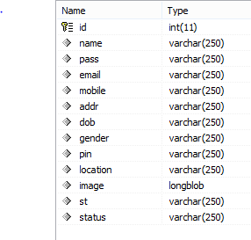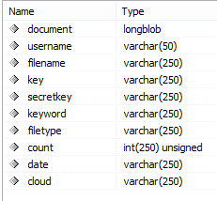

Fig.5.3.7.1 Database design

**5.3.8 TABLE DESIGN**

|  |  |  |
| --- | --- | --- |
| **S.NO** | **FIELD NAME** | **DATA TYPE** |
| 1 | id | INTEGER(11) |
| 2 | user name | VARCHAR(250) |
| 3 | Password | VARCHAR(250) |
| 4 | e mail | VARCHAR(250) |
| 5 | mobile | VARCHAR(250) |
| 6 | address | VARCHAR(250) |
| 7 | dob | VARCHAR(250) |
| 8 | gender | VARCHAR(250) |
| 9 | pin | VARCHAR(250) |
| 10 | location | VARCHAR(250) |
| 11 | image | longblob |
| 12 | st | VARCHAR(250) |
| 13 | status | VARCHAR(250) |

Table. 5.3.8.1 Register table

|  |  |  |
| --- | --- | --- |
| **S.NO** | **FIELD NAME** | **DATA TYPE** |
| 1 | document | longblob |
| 2 | User name | VARCHAR(50) |
| 3 | File name | VARCHAR(250) |
| 4 | key | VARCHAR(250) |
| 5 | Secret key | VARCHAR(250) |
| 6 | keyword | VARCHAR(250) |
| 7 | filetype | VARCHAR(250) |
| 8 | count | INTEGER(250) |
| 9 | date | VARCHAR(250) |
| 10 | cloud | VARCHAR(250) |

Table. 5.3.8.2 upload files

|  |  |  |
| --- | --- | --- |
| **S.NO** | **FIELD NAME** | **DATA TYPE** |
| 1 | user | VARCHAR(50) |
| 2 | File name | VARCHAR(250) |
| 3 | status | VARCHAR(50) |
| 4 | date | VARCHAR(50) |

Table. 5.3.8.3 Transaction

|  |  |  |
| --- | --- | --- |
| **S.NO** | **FIELD NAME** | **DATA TYPE** |
| 1 | id | INTEGER(50) |
| 2 | user | VARCHAR(250) |
| 3 | client | VARCHAR(50) |
| 4 | frame | VARCHAR(250) |
| 5 | E mail | VARCHAR(250) |
| 6 | key | VARCHAR(50) |
| 7 | status | VARCHAR(250) |

Table. 5.3.8.4 Request

|  |  |  |
| --- | --- | --- |
| **S.NO** | **FIELD NAME** | **DATA TYPE** |
| 1 | id | INTEGER(50) |
| 2 | File name | VARCHAR(50) |
| 3 | file | longblob |
| 4 | Secret key | VARCHAR(250) |
| 5 | status | VARCHAR(250) |
| 6 | time | date time |

Table. 5.3.8.5 Attack

* + 1. **MODULE SPECIFICATION**

1. **Smart contracts**
2. **Cyber-physical systems**
3. **Cloud manufacturing**
4. **Blockchain technology**
   * 1. **MODULE DESCRIPTION**

**1. Smart contracts**

SCs are permanently registered to the system as an application instance when deployed to a BC network. A new application instance is created for each instance created from the same SC code. A SC code contains variables and functions. In this application, when using SCs, it is discussed whether to store all jobs in a single SC or to create a new SC instance from the same SC code for each job. Both options will make the system work. However, if we compare these two methods, it can be understood why it would be more appropriate to create a new SC instance for each job.

1. **Cyber-physical systems**

TECHNOLOGICAL developments in manufacturing systems have changed the competitive factors in the sector. Before 1970s, cost, which is one of these factors, one the most important factor, whereas quality gained importance after the 70s. By 1990s, service and environmental factors gained importance and in the 21st century, information became the most important factor. The information is the foundation of the 4th industrial revolution, namely, Industry 4.0. The term Industry 4.0 collectively refers to a wide range of current concepts, including cyber-physical systems (CPS), internet of things (IoT), simulation, cloud computing, big data and advanced analysis techniques, service-oriented technologies, virtualisation and so on.

1. **Cloud manufacturing**

Combining recently emerged technologies with advanced manufacturing models and information technologies, Cloud Manufacturing is a new manufacturing paradigm that meets the needs of manufacturing systems. A number of significant researchers have been made to develop cloud manufacturing technologies, design the system architectures, and define cloud manufacturing and key characteristics. Cloud manufacturing is based on cloud computing. Cloud computing highlights two features: ease of access and shared use of resources. Cloud manufacturing, with these two feature of cloud computing, increases customers’ accessibility to manufacturing resources and capabilities through the Internet.

1. **Blockchain technology**

These features of cloud manufacturing make it inefficient in scalability, interoperability, reliability, security, data confidentiality, efficiency, continuity and flexibility. It is possible to use blockchain (BC) technology to solve many of these problems. BC technology offers an innovative approach to decentralized and fully distributed mechanism in industries and businesses. The BC technology basically can be considered as an immutable distributed ledger. BC is a technology that comes to the fore with guaranteeing the reliability of the data it stores. The BC technology has the following powerful characteristic.

**5.4 SYSTEM TESTING**

The purpose of testing is to discover errors. Testing is the process of trying to discover every conceivable fault or weakness in a work product. It provides a way to check the functionality of components, sub assemblies, assemblies and/or a finished product It is the process of exercising software with the intent of ensuring that the

Software system meets its requirements and user expectations and does not fail in an unacceptable manner. There are various types of test. Each test type addresses a specific testing requirement.

**5.4.1 TEST PLAN**

A test plan implies a series of desired course of action to be followed in accomplishingvarious testing methods. The Test Plan acts as a blue print for the action that is to befollowed. The software engineers create a computer program, its documentation andrelated data structures. The software developers is always responsible for testing theindividual units of the programs, ensuring that each performs the function for which itwas designed. The levels of testing include:

* Unit testing
* Integration testing
* Functional test
* System test

**5.4.1.1 Unit Testing:**

Unit testing involves the design of test cases that validate that the internal program logic is functioning properly, and that program inputs produce valid outputs. All decision branches and internal code flow should be validated. It is the testing of individual software units of the application .it is done after the completion of an individual unit before integration. This is a structural testing, that relies on knowledge of its construction and is invasive. Unit tests perform basic tests at component level and test a specific business process, application, and/or system configuration.

**5.4.1.2 Integration testing:**

Integration tests are designed to test integrated software components to determine if they actually run as one program. Testing is event driven and is more concerned with the basic outcome of screens or fields. Integration tests demonstrate that although the components were individually satisfaction, as shown by successfully unit testing, the combination of components is correct and consistent. Integration testing is specifically aimed at exposing the problems that arise from the combination of components.

**5.4.1.3 Functional test:**

Functional tests provide systematic demonstrations that functions tested are available as specified by the business and technical requirements, system documentation, and user manuals.

Functional testing is centered on the following items:

Valid Input : identified classes of valid input must be accepted.

Invalid Input : identified classes of invalid input must be rejected.

Functions : identified functions must be exercised.

Output : identified classes of application outputs must be exercised.

Systems/Procedures: interfacing systems or procedures must be invoked.

**5.4.1.4 System test:**

System testing ensures that the entire integrated software system meets requirements. It tests a configuration to ensure known and predictable results. An example of system testing is the configuration oriented system integration test. System testing is based on process descriptions and flows, emphasizing pre-driven process links and integration points.

**5.5 RESULTS**

* + 1. **CONCLUSION**
* With the capabilities of cloud manufacturing, resource owners and resource-seeking users can easily share resources through platforms. However, the reliability of the platforms is seen as a question mark for the users.
* In this study, a BC based application is introduced for users to make agreements among themselves without the need of any third party. The originality of this study is that the agreements are realized through the Ethereum network, which is a public BC network and supports SC.
* However, the application is designed in a hybrid structure. Thanks to the hybrid structure, users pay only for agreements that need to be secured. If the application was run in a completely public structure, all information would have to be stored on the public network, which would incur a serious cost.
* Apart from all this, in private networks, the fact that the network is controlled by a person or organization raises serious questions for users. In addition, the server infrastructure must be provided by a party for private networks. For these reasons, a hybrid structure was preferred.
* With this model, users will be able to make manufacturing agreements between each other and make their payments without any intermediaries.
  + 1. **LIMITATIONS**
* Innovative approaches for logging any access to the data in the cloud together with an attack is proposed.
* Approach allows the data owner to not only audit his content but also enforce strong back-end protection if needed.
* Moreover, one of the main features of our work is that it enables the data owner to attack even those copies of its data that were made without his knowledge.
  + 1. **FUTURE ENHANCEMENT**
* In this study, the use of BC technology in cloud manufacturing is attempted to be explained with an example application and it is aimed to shed light on the future studies.
* For future work, designed SCs may be developed and other services, such as machining as a service, will be directly integrated into the system.

**6. APPENDICES**

**6.1 SOURCE CODE**

**Index.java**

<?xml version="1.0" encoding="iso-8859-1" ?>

<!DOCTYPE html PUBLIC "-//W3C//DTD XHTML 1.0 Transitional//EN"

"http://www.w3.org/TR/xhtml1/DTD/xhtml1-transitional.dtd" >

<html xmlns="http://www.w3.org/1999/xhtml">

<head>

<meta charset="UTF-8">

<title>A Decentralized Cloud Firewall Framework with Resources Provisioning Cost Optimization</title>

<link rel="stylesheet" href="css/style.css" type="text/css">

<link rel="stylesheet" href="css/components.css" type="text/css">

<jsp:include page="script.jsp"></jsp:include>

</head>

<body>

<div id="header">

<div>

<div id="logo">

<a href="index.html"><img src="images/logo.png" alt="LOGO"></a>

</div>

<ul id="navigation">

<li class="selected">

<a href="index.jsp">Home</a>

</li>

<li >

<a href="register.jsp?status=register">Register</a>

</li>

<li >

<a href="login.jsp?status=login">Login</a>

</li>

<li>

<a href="#">Contact US</a>

</li>

</ul>

</div>

</div>

<div id="contents">

<div>

<div class="body" id="about">

<div id="main">

<h1>Abstract</h1>

&nbsp;&nbsp;&nbsp;&nbsp;&nbsp;&nbsp;&nbsp;&nbsp;&nbsp;&nbsp;&nbsp;&nbsp;&nbsp;&nbsp;&nbsp;&nbsp;&nbsp;&nbsp;&nbsp;&nbsp;&nbsp;&nbsp;&nbsp;<font color="#2a2a2a" size="4px"></font>

</div>

</div>

</div>

</div>

<div id="footer">

<p align="center">&nbsp;

<a href="#" style="color:gray;"><i>Copyright &#169; 2013 All rights reserved.</i></a>&nbsp;&nbsp;&nbsp;&nbsp;&nbsp;&nbsp;&nbsp;&nbsp;</p>

</div>

</body>

</html>

**Registration.java**

<?xml version="1.0" encoding="iso-8859-1" ?>

<!DOCTYPE html PUBLIC "-//W3C//DTD XHTML 1.0 Transitional//EN" "http://www.w3.org/TR/xhtml1/DTD/xhtml1-transitional.dtd">

<html xmlns="http://www.w3.org/1999/xhtml">

<head>

<meta charset="UTF-8">

<title>A Decentralized Cloud Firewall Framework with Resources Provisioning Cost Optimization</title>

<link rel="stylesheet" href="css/style.css" type="text/css">

<link rel="stylesheet" href="css/components.css" type="text/css">

<jsp:include page="script.jsp"></jsp:include>

</head>

<body>

<div id="header">

<div>

<div id="logo">

<a href="index.html"><img src="images/logo.png" alt="LOGO"></a>

</div>

<ul id="navigation">

<li>

<a href="index.jsp">Home</a>

</li>

<li class="selected">

<a href="register.jsp?status=register">Register</a>

</li>

<li >

<a href="login.jsp?status=login">Login</a>

</li>

<li>

<a href="#">Contact US</a>

</li>

</ul>

</div>

</div>

<div id="contents">

<div>

<div class="body" id="about">

<div id="main">

<h1>Register</h1>

<%

String labels=request.getParameter("status");

if(labels.equals("failed")){

%>

<%out.println("<br /><font size=\"5px\" color=\"red\" align=\"center\">&nbsp;&nbsp;&nbsp;&nbsp;&nbsp;&nbsp;&nbsp;&nbsp;&nbsp;&nbsp;&nbsp;&nbsp;&nbsp;&nbsp;&nbsp;&nbsp;&nbsp;&nbsp;&nbsp;&nbsp;Already Registered this Email Id</font></br /></br />"); %>

<%}

if(labels.equals("success")){

%>

<%out.println("<br /><font size=\"5px\" color=\"green\" align=\"center\">&nbsp;&nbsp;&nbsp;&nbsp;&nbsp;&nbsp;&nbsp;&nbsp;&nbsp;&nbsp;&nbsp;&nbsp;&nbsp;&nbsp;&nbsp;&nbsp;&nbsp;&nbsp;&nbsp;&nbsp;Successfully Register</font></br /></br />"); %>

<%}

%>

<form id="register" class="snform" name="register" method="post" action="register" >

<table width="600" height="221" align="center">

<tr>

<td width="600" height="128" ><table width="350" height="126">

<tr>

<td width="99" align="left" valign="middle"></td>

<td width="470" align="left" valign="middle"><label>

</label></td>

</tr>

<tr>

<td align="left" valign="middle"><h5>First Name:*</h5></td>

<td align="left" valign="middle"><label>

<input name="firstname" class="stext bgm" type="text" id="firstname" style="width:135px" />

</label></td>

</tr>

<tr>

<td align="left" valign="middle"><h5>Last Name:*</h5></td>

<td align="left" valign="middle"><label>

<input name="lastname" class="stext bgm" type="text" id="lastname" style="width:135px" />

</label></td>

</tr>

<tr>

<td align="left" valign="middle"><h5>Email ID:*</h5></td>

<td align="left" valign="middle"><label>

<input name="email" class="stext bgm" type="text" id="email" style="width:135px" />

</label></td>

</tr>

<tr>

<td align="left" valign="middle"><h5>Password:*</h5></td>

<td align="left" valign="middle"><input name="password" class="stext bgm" type="password" id="password" style="width:135px" /></td>

</tr>

<tr>

<td align="left" valign="middle"><h5>Confirm_Password:*</h5></td>

<td align="left" valign="middle"><label>

<input name="password_confirm" class="stext bgm" type="password" id="password_confirm" style="width:135px" />

</label></td>

</tr>

<tr>

<td align="left" valign="middle"><h5>Address:*</h5></td>

<td align="left" valign="middle"><label>

<textarea name="address" class="stext bgm" id="address" style="width:135px"></textarea>

</label></td>

</tr>

<tr>

<td align="left" valign="middle"><h5>Contact Number:*</h5></td>

<td align="left" valign="middle"><label>

<input name="number" type="text" class="stext bgm" id="number" style="width:135px" maxlength="10" />

</label></td>

</tr>

</table></td>

</tr>

<tr>

<td height="26" align="center" valign="middle">&nbsp;</td>

</tr>

<tr>

<td height="32" align="center" valign="middle"><label>

<button class="search_btn">Register</button>

</label></td>

</tr>

<tr>

<td height="21" align="center" valign="middle">&nbsp;</td>

</tr>

</table>

</form>

</div>

</div>

</div>

</div>

<div id="footer">

<p align="center">&nbsp;

<a href="#" style="color:gray;"><i>Copyright &#169; 2013 All rights reserved.</i></a>&nbsp;&nbsp;&nbsp;&nbsp;&nbsp;&nbsp;&nbsp;&nbsp;</p>

</div>

</body>

</html>

**Attributelogin.java**

<?xml version="1.0" encoding="iso-8859-1" ?>

<!DOCTYPE html PUBLIC "-//W3C//DTD XHTML 1.0 Transitional//EN" "http://www.w3.org/TR/xhtml1/DTD/xhtml1-transitional.dtd">

<html xmlns="http://www.w3.org/1999/xhtml">

<head>

<meta charset="UTF-8">

<title>A Decentralized Cloud Firewall Framework with Resources Provisioning Cost Optimization</title>

<link rel="stylesheet" href="css/style.css" type="text/css">

<link rel="stylesheet" href="css/components.css" type="text/css">

<jsp:include page="script.jsp"></jsp:include>

</head>

<body>

<div id="header">

<div>

<div id="logo">

<a href="index.html"><img src="images/logo.png" alt="LOGO"></a>

</div>

<ul id="navigation">

<li>

<a href="index.jsp">Home</a>

</li>

<li >

<a href="register.jsp?status=register">Register</a>

</li>

<li class="selected">

<a href="login.jsp?status=login">Login</a>

</li>

<li>

<a href="#">Contact US</a>

</li>

</ul>

</div>

</div>

<div id="contents">

<div>

<div class="body" id="about">

<div id="main">

<h1>Login</h1>

<%

String labels=request.getParameter("status");

if(labels.equals("failed")){%><%out.println("<br /><font size=\"5px\" color=\"red\" align=\"center\">&nbsp;&nbsp;&nbsp;&nbsp;&nbsp;&nbsp;&nbsp;&nbsp;&nbsp;&nbsp;&nbsp;&nbsp;&nbsp;&nbsp;&nbsp;&nbsp;&nbsp;&nbsp;&nbsp;&nbsp;Incorrect Email-Id & Password</font></br /></br />"); %>

<%}%>

<form name="second" class="snform" id="login-form" action="logincheck.jsp" method="post">

<label class="req label">Email ID</label><br />

<input type="text" class="stext bgm" id="user" name="user" value="" placeholder = "E-Mail ID"/><br />

<label class="req label">Password</label><br />

<input type="password" class="stext bgp" id="pass" name="pass" value="" placeholder = "Password"/><br />

<input type="hidden" name="formsubmitted" value="TRUE" />

<br/>

<div align="left">

<button class="search_btn">Login</button>

</div>

</form>

</div>

</div>

</div>

</div>

<div id="footer">

<p align="center">&nbsp;

<a href="#" style="color:gray;"><i>Copyright &#169; 2013 All rights reserved.</i></a>&nbsp;&nbsp;&nbsp;&nbsp;&nbsp;&nbsp;&nbsp;&nbsp;</p>

</div>

</body>

</html>

**cloud.java**

<?xml version="1.0" encoding="iso-8859-1" ?>

<%@ page language="java" import="java.util.*" import="java.io.*"%>

<jsp:useBean id="ker" class="model.CommonModel"></jsp:useBean>

<%@ page language="java" contentType="text/html; charset=iso-8859-1"

pageEncoding="ISO-8859-1"%>

<%@ page import="java.io.*" %>

<%@ page import="java.sql.*" %>

<%@ page import="java.util.Calendar" %>

<%@ page import="java.text.SimpleDateFormat" %>

<!DOCTYPE html PUBLIC "-//W3C//DTD HTML 4.01 Transitional//EN" "http://www.w3.org/TR/html4/loose.dtd">

<html>

<head>

<meta http-equiv="Content-Type" content="text/html; charset=ISO-8859-1">

<title>A Decentralized Cloud Firewall Framework with Resources Provisioning Cost Optimization</title>

<link rel="stylesheet" href="css/style.css" type="text/css">

<link rel="stylesheet" href="css/components.css" type="text/css">

<jsp:include page="script.jsp"></jsp:include>

</head>

<body>

<% Object memberids=session.getAttribute("id");

String memberid=memberids.toString();

Object memberemails=session.getAttribute("email");

String memberemail=memberemails.toString();

Object membernames=session.getAttribute("yname");

String membername=membernames.toString();

Object membertypes=session.getAttribute("utype");

String membertype=membernames.toString();

String labels=request.getParameter("labels");

String sta=request.getParameter("sta");

%>

<div style="width:960px;height:auto;padding:0 auto;margin:0 auto; border:0px solid green";>

<div style="width:960px;height:auto;float:left; border:0px solid green";>

<div style="width:960px;height:150px;float:left; border:0px solid green;background-color:green;">

</div>

<div style="width:960px;height:auto;float:left; border:0px solid green";>

<div style="width:960px;height:40px;border:1px solid green;padding:0 auto;margin:0 auto;margin-top:10px;">

<ul id="navigation1">

<li >

<a href="index.jsp">Home</a>

</li>

<li class="selected">

<a href="#">Cloud</a>

</li>

<li >

<a href="cloud.jsp?labels=oreg&sta=noth">Registration details</a>

</li>

<li >

<a href="cloud.jsp?labels=cproductdet&sta=noth">Product details</a>

</li>

<li >

<a href="cloud.jsp?labels=ctransactiondet&sta=noth">Transactions details</a>

</li>

<li>

<a href="logout.jsp">Logout</a>

</li>

</ul>

</div>

</div>

<div style="width:960px;height:auto;float:left; margin-top:10px;margin-bottom:10px;border:1px solid green";>

<div style="width:940px;height:auto;float:left; margin-left:10px;margin-top:10px;margin-bottom:10px;border:1px solid green";>

<div style="width:930px;height:auto;float:left; padding-left:5px;margin-left:0px;margin-top:10px;margin-bottom:10px;border-bottom:1px solid green";>

<font color="green" size="6px";>Cloud

&nbsp;&nbsp;&nbsp;&nbsp;&nbsp;&nbsp;&nbsp;&nbsp;&nbsp;&nbsp;

&nbsp;&nbsp;&nbsp;&nbsp;&nbsp;&nbsp;&nbsp;&nbsp;&nbsp;&nbsp;

&nbsp;&nbsp;&nbsp;&nbsp;&nbsp;&nbsp;&nbsp;&nbsp;&nbsp;&nbsp;

&nbsp;&nbsp;&nbsp;&nbsp;&nbsp;&nbsp;&nbsp;&nbsp;&nbsp;&nbsp;

&nbsp;&nbsp;&nbsp;&nbsp;&nbsp;&nbsp;&nbsp;&nbsp;&nbsp;&nbsp;

</font><font color="BLUE" size="5px";><i>Welcome, <%=membernames %></i></font><br /><br />

<!----find friends end>-->

</div>

<% if(labels.equals("cproductdet")){

if(sta.equals("failed"))

{

%>

<font color="red" size="5px";>&nbsp;&nbsp;&nbsp;&nbsp;&nbsp;&nbsp;&nbsp;&nbsp;&nbsp;&nbsp;&nbsp;&nbsp;&nbsp;&nbsp;&nbsp;&nbsp;&nbsp;&nbsp;&nbsp;&nbsp;&nbsp;&nbsp;&nbsp;&nbsp;&nbsp;&nbsp;&nbsp;&nbsp;&nbsp;&nbsp;&nbsp;&nbsp;&nbsp;&nbsp;&nbsp;&nbsp;&nbsp;&nbsp;&nbsp;&nbsp;&nbsp;&nbsp;&nbsp;Process Failed</font><br /><br />

<%

}

if(sta.equals("success"))

{

%>

<font color="green" size="5px";>&nbsp;&nbsp;&nbsp;&nbsp;&nbsp;&nbsp;&nbsp;&nbsp;&nbsp;&nbsp;&nbsp;&nbsp;&nbsp;&nbsp;&nbsp;&nbsp;&nbsp;&nbsp;&nbsp;&nbsp;&nbsp;&nbsp;&nbsp;&nbsp;&nbsp;&nbsp;&nbsp;&nbsp;&nbsp;&nbsp;&nbsp;&nbsp;&nbsp;&nbsp;&nbsp;&nbsp;&nbsp;&nbsp;&nbsp;&nbsp;&nbsp;&nbsp;&nbsp;Successfully Added</font><br /><br />

<%

}

%>

<div style="width:690px;height:auto;float:left; margin-left:10px;margin-bottom:20px;padding-left:10px;padding-top:10px;padding-bottom:10px;border:0px solid green";>

<!--table start-->

<div class="testtablegenerator" ><font color="green" size="5px";>View Products</font><br /><br />

<table >

<tr>

<td>

PID

</td>

<td>

BRANDS

</td>

<td >

LAPTOP_MODEL

</td>

<td >

PROCESSOR

</td>

<td >

RATE

</td>

<td >

HARDDISK_in_GB

</td>

<td >

RAM_in_GB

</td>

<td >

MFG_COUNTRY

</td>

<td >

CITY

</td>

</tr>

<%

String ad11=new String("");

String ad12=new String("");

String ad13=new String("");

String ad14=new String("");

String ad15=new String("");

String ad16=new String("");

String ad17=new String("");

String ad18=new String("");

String ad19=new String("");

ResultSet rs12;

Class.forName("sun.jdbc.odbc.JdbcOdbcDriver");

Connection con1 = DriverManager.getConnection("jdbc:odbc:apriori","sa","test");

Statement st=con1.createStatement();

String sql12 = "select * from datas" ;

st.executeQuery (sql12);

rs12 = st.getResultSet();

while (rs12.next ())

{

ad11=rs12.getString("SNO");

ad12=rs12.getString("BRANDS");

ad13=rs12.getString("LAPTOP_MODEL");

ad14=rs12.getString("PROCESSOR");

ad15=rs12.getString("RATE");

ad16=rs12.getString("HARDDISK_in_GB");

ad17=rs12.getString("RAM_in_GB");

ad18=rs12.getString("MFG_COUNTRY");

ad19=rs12.getString("AVAILABLE_CITY");

%>

<tr>

<td>

<%=ad11%>

</td>

<td>

<%=ad12%>

</td>

<td>

<%=ad13%>

</td>

<td>

<%=ad14%>

</td>

<td>

<%=ad15%>

</td>

<td>

<%=ad16%>

</td>

<td>

<%=ad17%>

</td>

<td>

<%=ad18%>

</td>

<td>

<%=ad19%>

</td>

<%} %>

</tr>

</table>

</div>

</div>

<% } %>

<% if(labels.equals("oreg")){

if(sta.equals("failed"))

{

%>

<font color="red" size="5px";>&nbsp;&nbsp;&nbsp;&nbsp;&nbsp;&nbsp;&nbsp;&nbsp;&nbsp;&nbsp;&nbsp;&nbsp;&nbsp;&nbsp;&nbsp;&nbsp;&nbsp;&nbsp;&nbsp;&nbsp;&nbsp;&nbsp;&nbsp;&nbsp;&nbsp;&nbsp;&nbsp;&nbsp;&nbsp;&nbsp;&nbsp;&nbsp;&nbsp;&nbsp;&nbsp;&nbsp;&nbsp;&nbsp;&nbsp;&nbsp;&nbsp;&nbsp;&nbsp;Process Failed</font><br /><br />

<%

}

if(sta.equals("success"))

{

%>

<font color="green" size="5px";>&nbsp;&nbsp;&nbsp;&nbsp;&nbsp;&nbsp;&nbsp;&nbsp;&nbsp;&nbsp;&nbsp;&nbsp;&nbsp;&nbsp;&nbsp;&nbsp;&nbsp;&nbsp;&nbsp;&nbsp;&nbsp;&nbsp;&nbsp;&nbsp;&nbsp;&nbsp;&nbsp;&nbsp;&nbsp;&nbsp;&nbsp;&nbsp;&nbsp;&nbsp;&nbsp;&nbsp;&nbsp;&nbsp;&nbsp;&nbsp;&nbsp;&nbsp;&nbsp;Successfully Added</font><br /><br />

<%

}

%>

<div style="width:690px;height:auto;float:left; margin-left:10px;margin-bottom:20px;padding-left:10px;padding-top:10px;padding-bottom:10px;border:0px solid green";>

<!--table start-->

<div class="testtablegenerator" ><font color="green" size="5px";>View Overall Registration</font><br /><br />

<table >

<tr>

<td>

ID

</td>

<td >

Type

</td>

<td >

Email

</td>

<td >

Name

</td>

<td >

Reg.Date

</td>

</tr>

<%

String ad11=new String("");

String ad12=new String("");

String ad13=new String("");

String ad14=new String("");

String ad15=new String("");

String ad16=new String("");

String ad17=new String("");

String ad18=new String("");

ResultSet rs12;

Class.forName("sun.jdbc.odbc.JdbcOdbcDriver");

Connection con1 = DriverManager.getConnection("jdbc:odbc:apriori","sa","test");

Statement st=con1.createStatement();

String sql12 = "select * from register" ;

st.executeQuery (sql12);

rs12 = st.getResultSet();

while (rs12.next ())

{

ad11=rs12.getString("id");

ad12=rs12.getString("utype");

ad13=rs12.getString("email");

ad14=rs12.getString("yname");

ad15=rs12.getString("cdate");

%>

<tr>

<td>

<%=ad11 %>

</td>

<td>

<%=ad12%>

</td>

<td>

<%=ad13%>

</td>

<td>

<%=ad14%>

</td>

<td>

<%=ad15%>

</td>

<%} %>

</tr>

</table>

</div>

</div>

<% } %>

<% if(labels.equals("ctransactiondet")){

if(sta.equals("failed"))

{

%>

<font color="red" size="5px";>&nbsp;&nbsp;&nbsp;&nbsp;&nbsp;&nbsp;&nbsp;&nbsp;&nbsp;&nbsp;&nbsp;&nbsp;&nbsp;&nbsp;&nbsp;&nbsp;&nbsp;&nbsp;&nbsp;&nbsp;&nbsp;&nbsp;&nbsp;&nbsp;&nbsp;&nbsp;&nbsp;&nbsp;&nbsp;&nbsp;&nbsp;&nbsp;&nbsp;&nbsp;&nbsp;&nbsp;&nbsp;&nbsp;&nbsp;&nbsp;&nbsp;&nbsp;&nbsp;Process Failed</font><br /><br />

<%

}

if(sta.equals("success"))

{

%>

<font color="green" size="5px";>&nbsp;&nbsp;&nbsp;&nbsp;&nbsp;&nbsp;&nbsp;&nbsp;&nbsp;&nbsp;&nbsp;&nbsp;&nbsp;&nbsp;&nbsp;&nbsp;&nbsp;&nbsp;&nbsp;&nbsp;&nbsp;&nbsp;&nbsp;&nbsp;&nbsp;&nbsp;&nbsp;&nbsp;&nbsp;&nbsp;&nbsp;&nbsp;&nbsp;&nbsp;&nbsp;&nbsp;&nbsp;&nbsp;&nbsp;&nbsp;&nbsp;&nbsp;&nbsp;Successfully Added</font><br /><br />

<%

}

%>

<div style="width:690px;height:auto;float:left; margin-left:10px;margin-bottom:20px;padding-left:10px;padding-top:10px;padding-bottom:10px;border:0px solid green";>

<!--table start-->

<div class="testtablegenerator" ><font color="green" size="5px";>Transaction Details</font><br /><br />

<table >

<tr>

<td>

TRANSACTION ID

</td>

<td >

TRANSACTION DATE

</td>

<td >

ITEMS

</td>

</tr>

<%

String ad11=new String("");

String ad12=new String("");

String ad13=new String("");

String ad14=new String("");

String ad15=new String("");

String ad16=new String("");

String ad17=new String("");

String ad18=new String("");

ResultSet rs12;

Class.forName("sun.jdbc.odbc.JdbcOdbcDriver");

Connection con1 = DriverManager.getConnection("jdbc:odbc:apriori","sa","test");

Statement st=con1.createStatement();

String sql12 = "select * from logdatabase WHERE RATE='1'" ;

st.executeQuery (sql12);

rs12 = st.getResultSet();

while (rs12.next ())

{

ad11=rs12.getString("trid");

ad12=rs12.getString("trdate");

ad13=rs12.getString("items");

%>

<tr>

<td>

<%=ad11 %>

</td>

<td>

<%=ad12%>

</td>

<td>

<%=ad13%>

</td>

<%} %>

</tr>

</table>

</div>

</div>

<% } %>

</div>

<div style="width:960px;height:100px;float:left; border:0px solid green;background-color:green";>

<div class="footer1_rev_3x1"><div style="font-size:12px;padding-left:380px;">Copyright &#169; 2013 All rights reserved.</div></div>

</div>

</div>

</div>

</div>

</body>

</html>

**Attackpage.java**

<%@ page language="java" contentType="text/html; charset=ISO-8859-1"

pageEncoding="ISO-8859-1"%>

<%@ page import="java.sql.*"%>

<%@ page import="java.io.*"%>

<%@ page import="java.io.*,java.sql.*,java.util.*,java.text.*,java.text.SimpleDateFormat" %>

<%@ page language="java" import="java.io.*" %>

<%@ page language="java" import="java.util.*" %>

<%@ page language="java" import="java.lang.*" %>

<%@ page language="java" import="java.net.*" %>

<!DOCTYPE html PUBLIC "-//W3C//DTD HTML 4.01 Transitional//EN" "http://www.w3.org/TR/html4/loose.dtd">

<html>

<head>

<meta http-equiv="Content-Type" content="text/html; charset=ISO-8859-1">

<title>Do DDOS Attacks</title>

</head>

<body>

<%

int st;

int SNO=0,gsno=0;

java.util.Date now = new java.util.Date();

String DATE_FORMAT = "dd-MM-YYYY";

SimpleDateFormat sdf = new SimpleDateFormat(DATE_FORMAT);

String strDateNew = sdf.format(now) ;

String webRootPath2 = getServletContext().getRealPath("/").replace('\\', '/');

if (webRootPath2.contains("/.metadata/.plugins/org.eclipse.wst.server.core/tmp0/wtpwebapps/")){

webRootPath2=webRootPath2.replace("/.metadata/.plugins/org.eclipse.wst.server.core/tmp0/wtpwebapps/", "/");

String type=request.getParameter("folder");

String rem=request.getParameter("remove");

Class.forName("sun.jdbc.odbc.JdbcOdbcDriver");

Connection con=DriverManager.getConnection("jdbc:odbc:CNSMS","sa","test");

if(rem != null && !rem.isEmpty())

{

System.out.println("remove1"+rem);

String removefiles=webRootPath2+"WebContent/"+type+"/"+rem;

File f=new File(removefiles);

f.delete();

try

{

Statement st1=con.createStatement();

ResultSet rs1=st1.executeQuery("select max(rid) from activities");

if(rs1.next())

{

gsno=rs1.getInt(1);

gsno++;

}

else

{

gsno=1;

}

rs1.close();

}

catch(Exception e)

{

System.out.println("ERROR"+e);

}

Statement st2=con.createStatement();

st=st2.executeUpdate("insert into activities values('"+gsno+"','"+type+"','"+rem+"','Remove','"+strDateNew+"') ");

}

else

{

System.out.println("remove2"+rem);

}

System.out.println(type);

if(type != null && !type.isEmpty())

{

//webRootPath2=webRootPath2+type+"/";

webRootPath2=webRootPath2+"WebContent/"+type+"/";

System.out.println("first");

System.out.println(webRootPath2);

try{

File dirName = new File(webRootPath2);

if (dirName.exists()&& dirName.isDirectory())

{

//out.print("path: " + dirName.getAbsolutePath() + "<br>");

String[] allFiles = dirName.list();

for (int i=0; i < allFiles.length; i++)

{

if(allFiles[i].contains("."))

{

//out.println(allFiles[i] + "<br>");

%>

<%=allFiles[i]%><a href='attackpage.jsp?folder=<%=type%>&remove=<%=allFiles[i]%>'>Remove</a><br />

<%

}

else

{

}

//out.println(allFiles[i] + "<br>");

//out.println(dirName.getName() + "<br>");

%>

<%

}

}

}

catch (IOException ex){

out.println("Exception Occured");

}

}

else

{

webRootPath2=webRootPath2+"WebContent/";

System.out.println("second");

System.out.println(webRootPath2);

try{

File dirName = new File(webRootPath2);

if (dirName.exists()&& dirName.isDirectory())

{

//out.print("path: " + dirName.getAbsolutePath() + "<br>");

String[] allFiles = dirName.list();

for (int i=0; i < allFiles.length; i++)

{

if(allFiles[i].contains(".") || allFiles[i].contains("css") || allFiles[i].contains("images") || allFiles[i].contains("WEB-INF") || allFiles[i].contains("META-INF") || allFiles[i].contains("cloudbackup") )

{

// out.println(allFiles[i] + "<br>");

}

else

{

%>

<a href='attackpage.jsp?folder=<%=allFiles[i]%>'><%=allFiles[i]%></a>

<%

}

//out.println(allFiles[i] + "<br>");

//out.println(dirName.getName() + "<br>");

%>

<%

}

}

}

catch (IOException ex){

out.println("Exception Occured");

}

}

}

%>

</body>

</html>

**6.2 SCREENSHOTS**

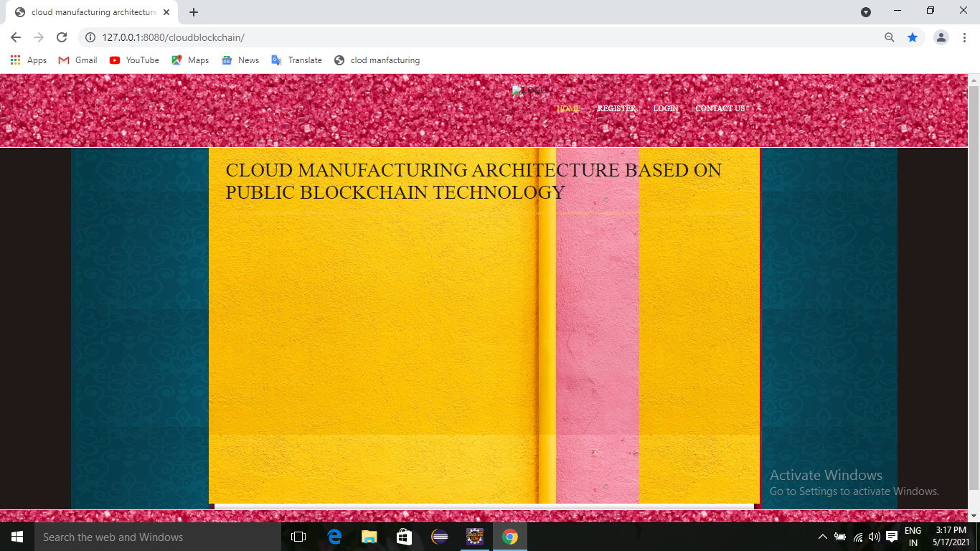

**Fig 6.2.1 Home page**

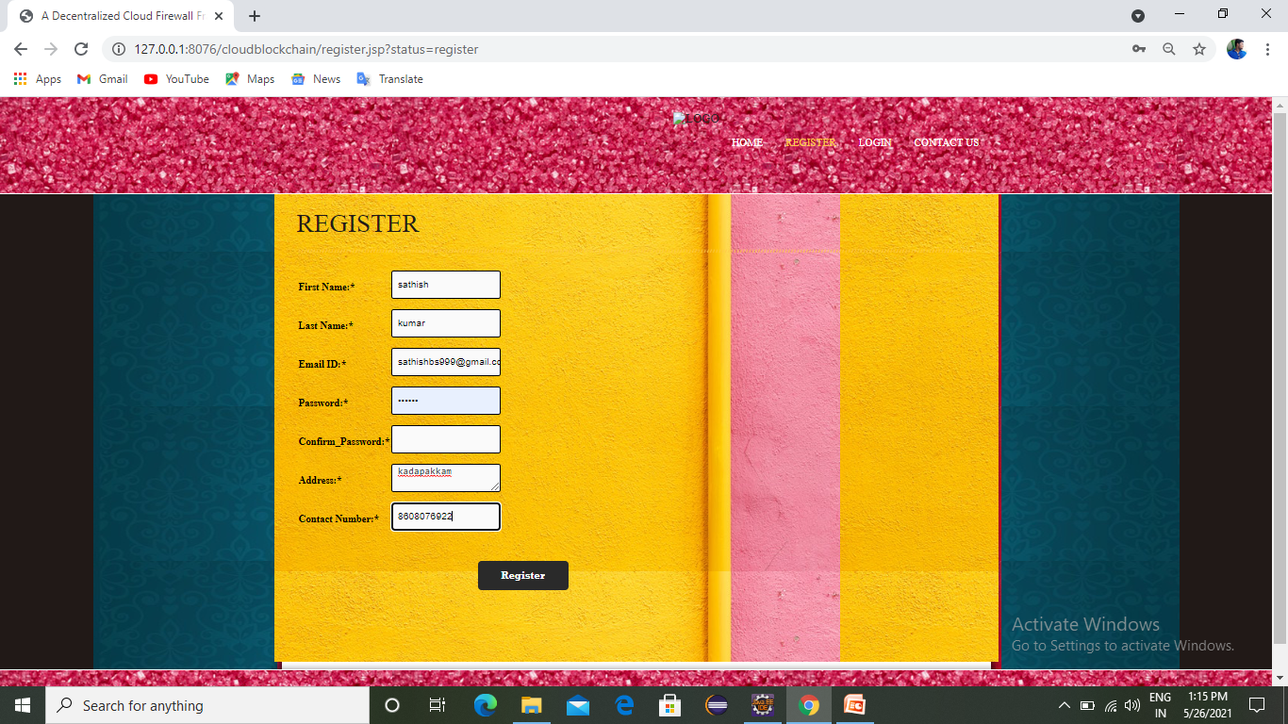

**Fig 6.2.2 Register page**

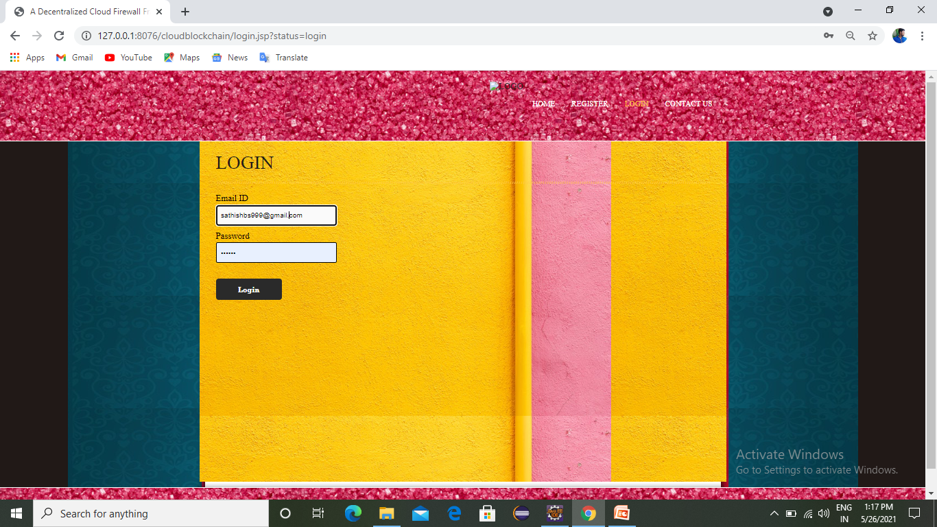

**Fig 6.2.3 Login page**

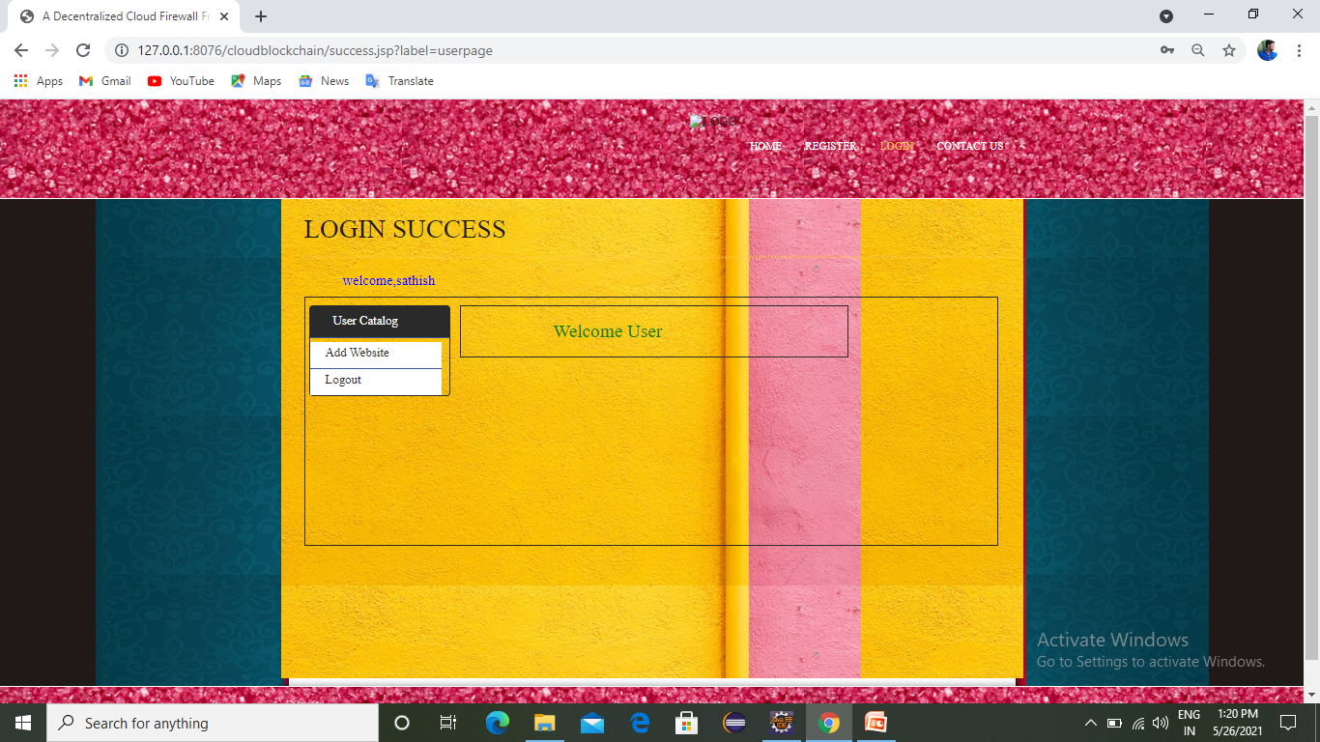

**Fig 6.2.4 Add website**

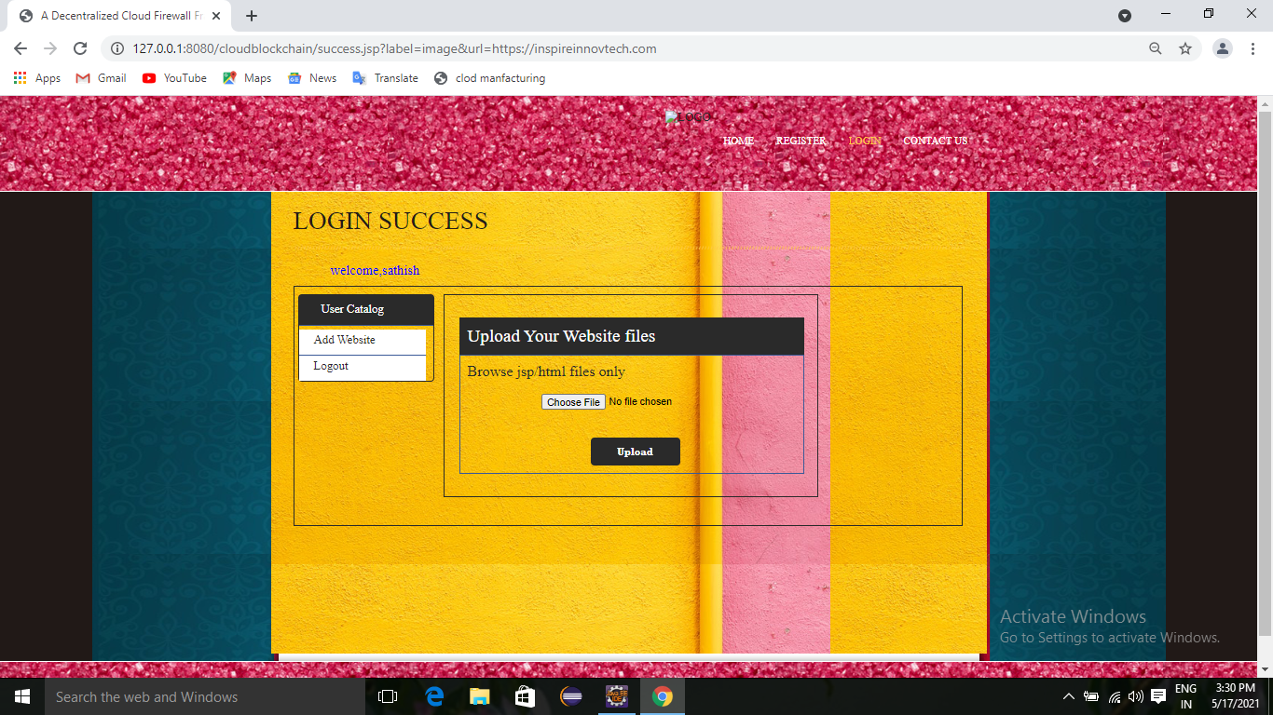

**Fig 6.2.5 File upload**

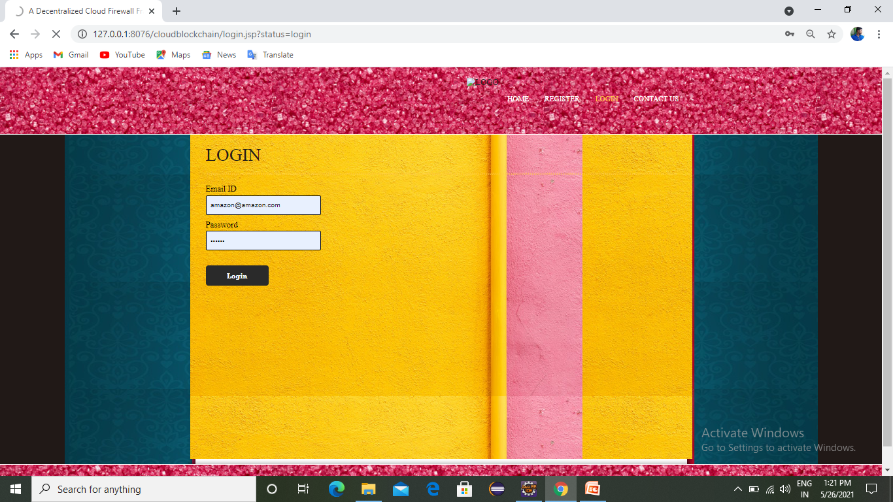

**Fig 6.2.6 Admin login**

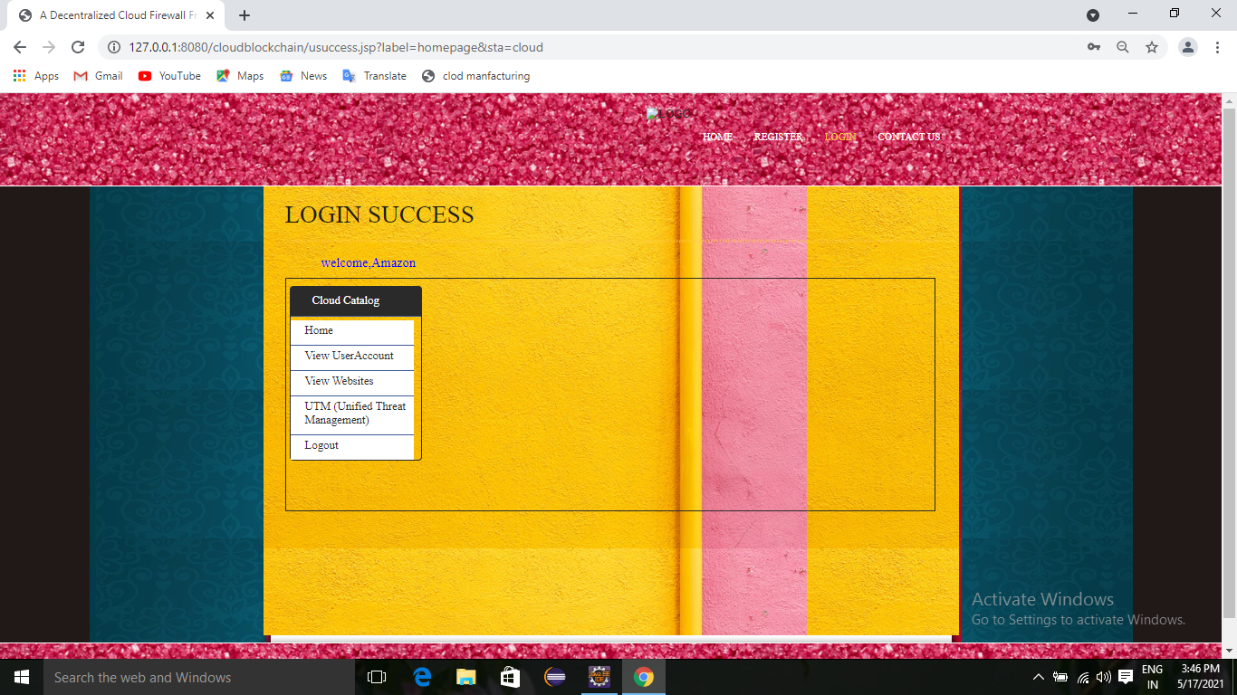

**Fig 6.2.7 Login success**

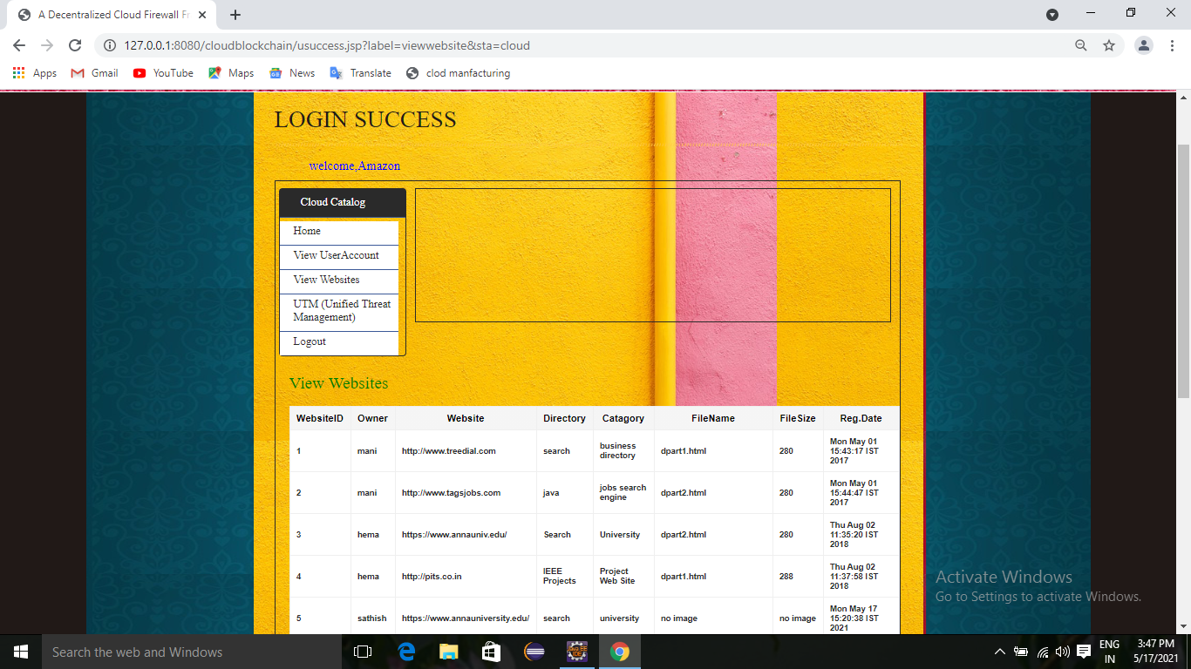

**Fig 6.2.8 view websites**

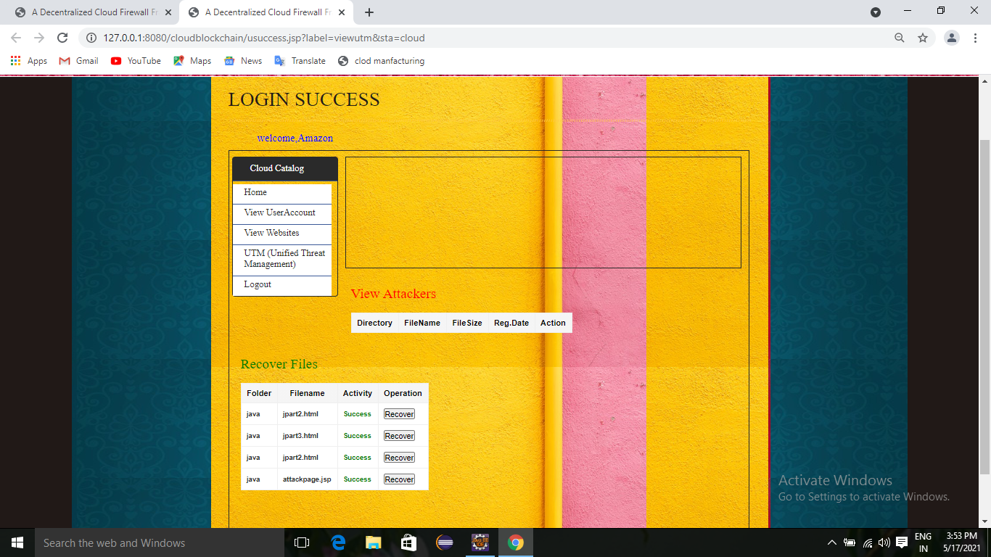

**Fig 6.2.9 View attackers**

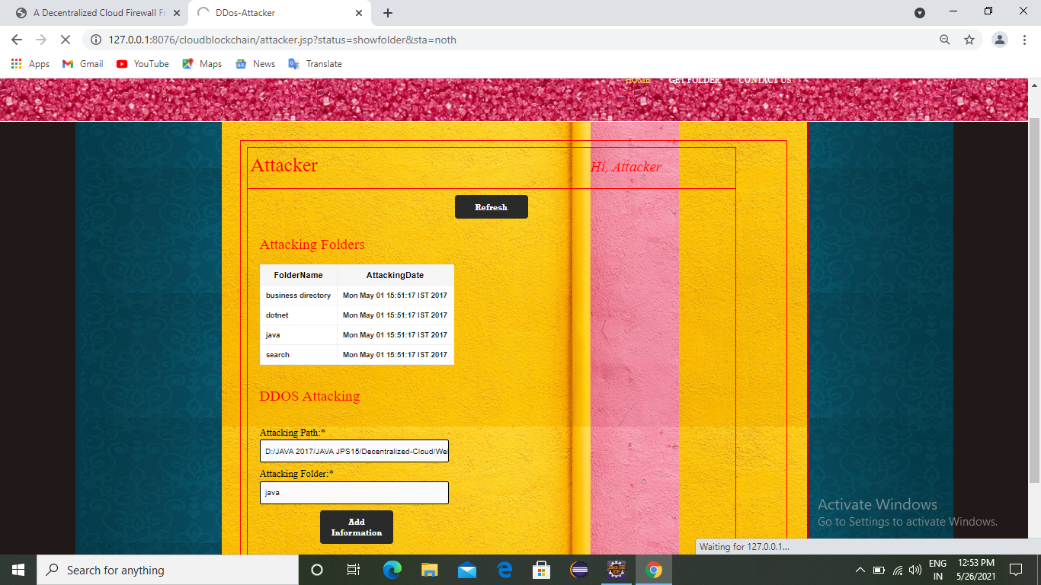

**Fig 6.2.10 Attacking folder**

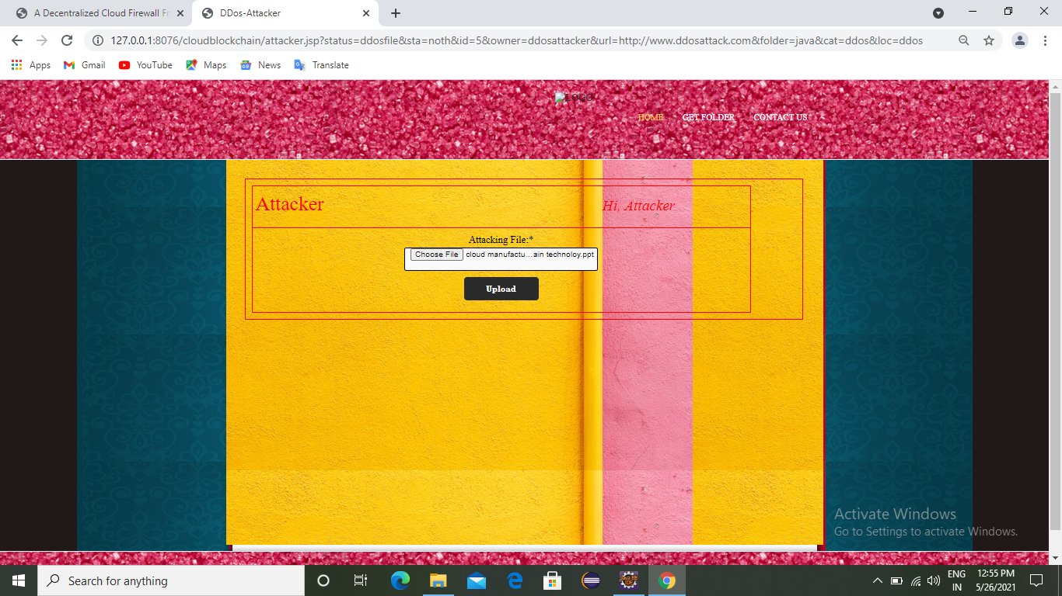

**Fig 6.2.11 Attack file upload**

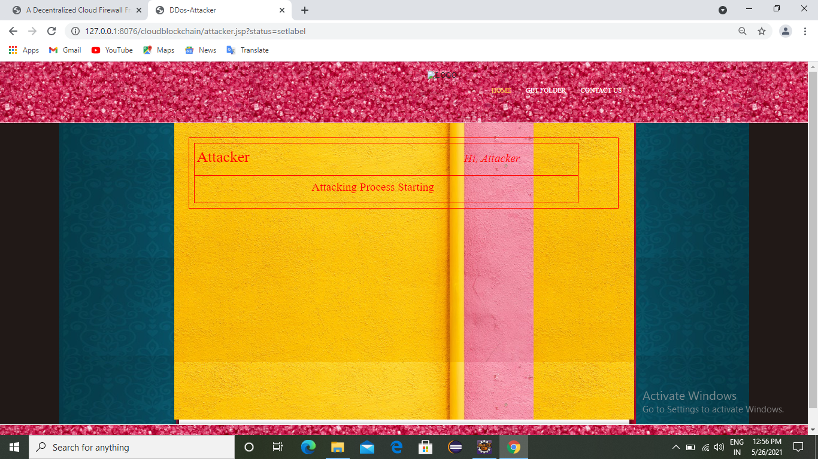

**Fig 6.2.12 Attacking process**

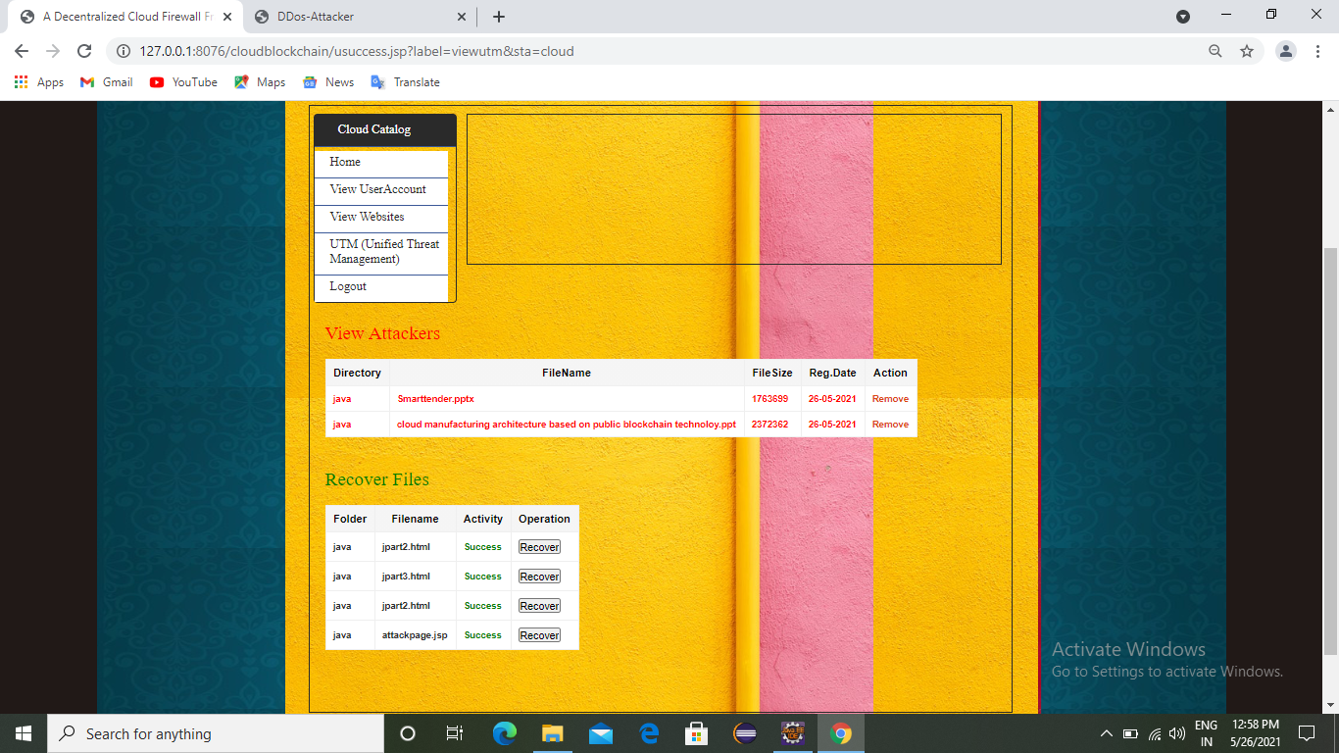

**Fig 6.2.13 Recover files**

**REFERENCE**

[1] D. Wu, D. Rosen, and D. Schaefer, Cloud-Based Design and Manufacturing: Status and Promise, 07 2014, pp. 1–24.

[2] K. Zhou, Taigang Liu, and Lifeng Zhou, “Industry 4.0: Towards future industrial opportunities and challenges,” in 2015 12th International Conference on Fuzzy Systems and Knowledge Discovery (FSKD), Aug 2015, pp. 2147–2152.

[3] Y. Liu and X. Xu, “Industry 4.0 and cloud manufacturing: A comparative analysis,” Journal of Manufacturing Science and Engineering, vol. 139, no. 3, pp. 034 701–034 701–8, Oct 2016. [Online]. Available: http://dx.doi.org/10.1115/1.4034667

[4] Y. Lu, “Industry 4.0: A survey on technologies, applications and open research issues,” Journal of Industrial Information Integration, vol. 6, pp. 1–10, jun 2017.

[5] H. Lasi, P. Fettke, H.-G. Kemper, T. Feld, and M. Hoffmann, “Industry 4.0,” Business.

[6] J. Lee, B. Bagheri, and H.-A. Kao, “A cyber-physical systems architecture for industry 4.0-based manufacturing systems,” Manufacturing Letters, vol. 3, pp. 18 – 23, 2015. [Online]. Available: http://www.sciencedirect.com/science/article/pii/S221384631400025X

[7] D. Georgakopoulos, P. Jayaraman, M. Fazia, M. Villari, and R. Ranjan, “Internet of things and edge cloud computing roadmap for manufacturing,” IEEE Cloud Computing, vol. 3, no. 04, pp. 66–73, jan 2016.

[8] J. Wan, S. Tang, Z. Shu, D. Li, S. Wang, M. Imran, and A. V. Vasilakos, “Software-defined industrial internet of things in the context of industry 4.0,” IEEE Sensors Journal, vol. 16, no. 20, pp. 7373–7380, Oct 2016.

[9] W. He and L. Xu, “A state-of-the-art survey of cloud manufacturing,” International Journal of Computer Integrated Manufacturing, vol. 28, no. 3, pp. 239–250, 2015.

[10] G. Škulj, R. Vrabiˇc, P. Butala, and A. Sluga, “Decentralised network architecture for cloud manufacturing,” International Journal of Computer Integrated Manufacturing, vol. 30, no. 4-5, pp. 395–408, 2017. [Online]. Available: https://doi.org/10.1080/0951192X.2015.1066861

1.
2.